TC-DM-001
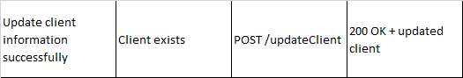
Client Before Update
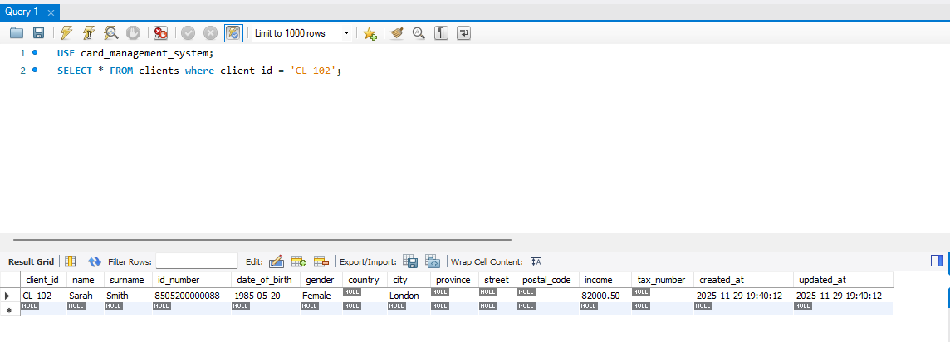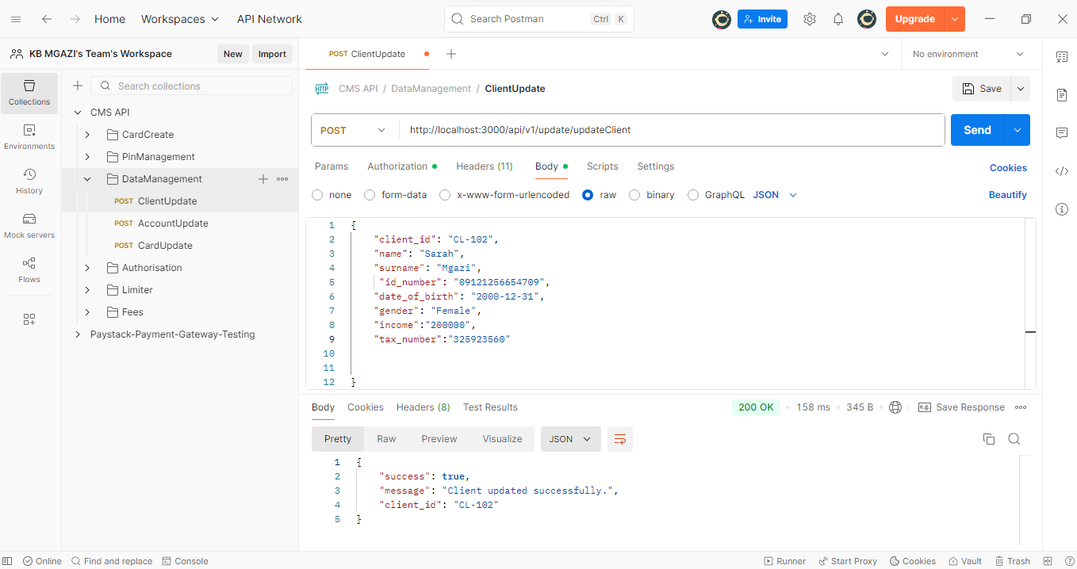
Request:
{
"client_id": "CL-102",
"name": "Sarah",
"surname": "Mgazi",
"id_number": "09121256654709",
"date_of_birth": "2000-12-31",
"gender": "Female",
"income":"200000",
"tax_number":"325923560"

}

Response:
{
"success": true,
"message": "Client updated successfully.",
"client_id": "CL-102"
}

